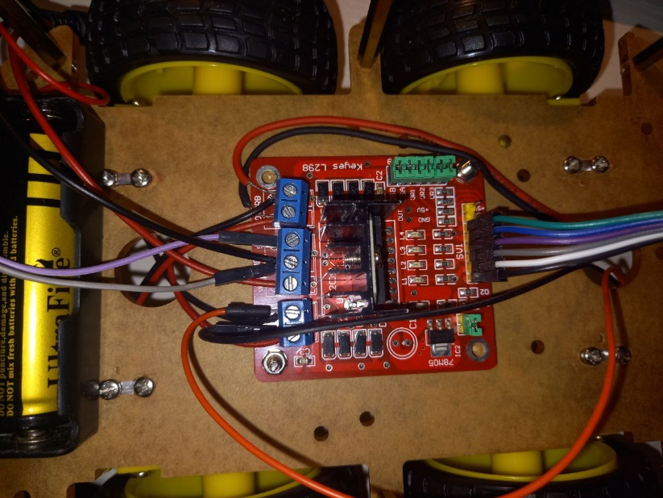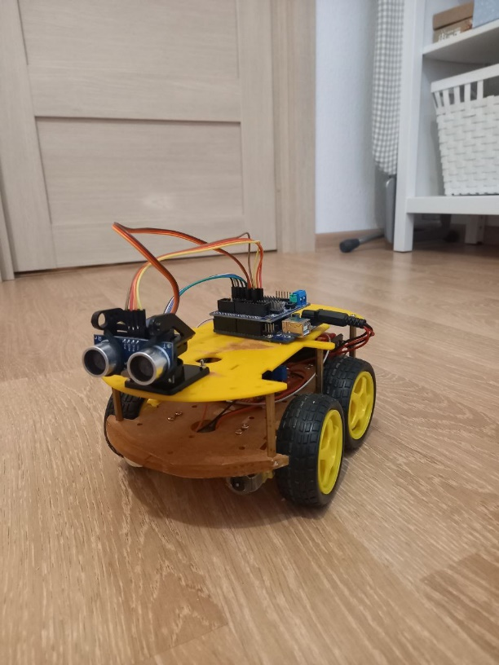

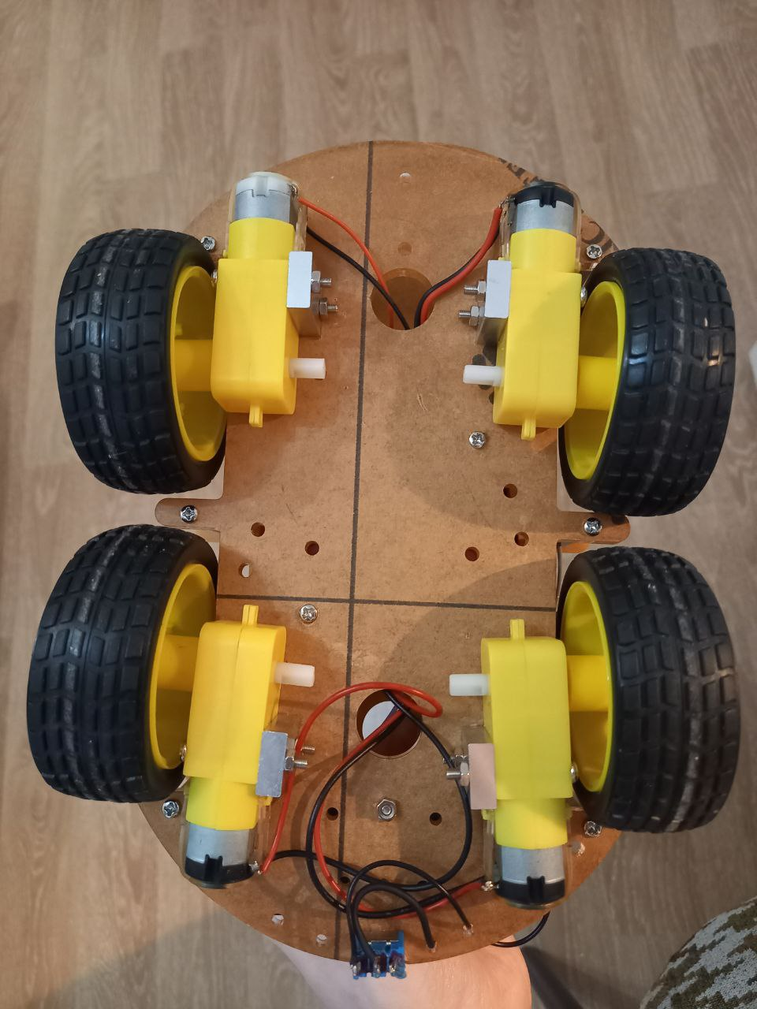

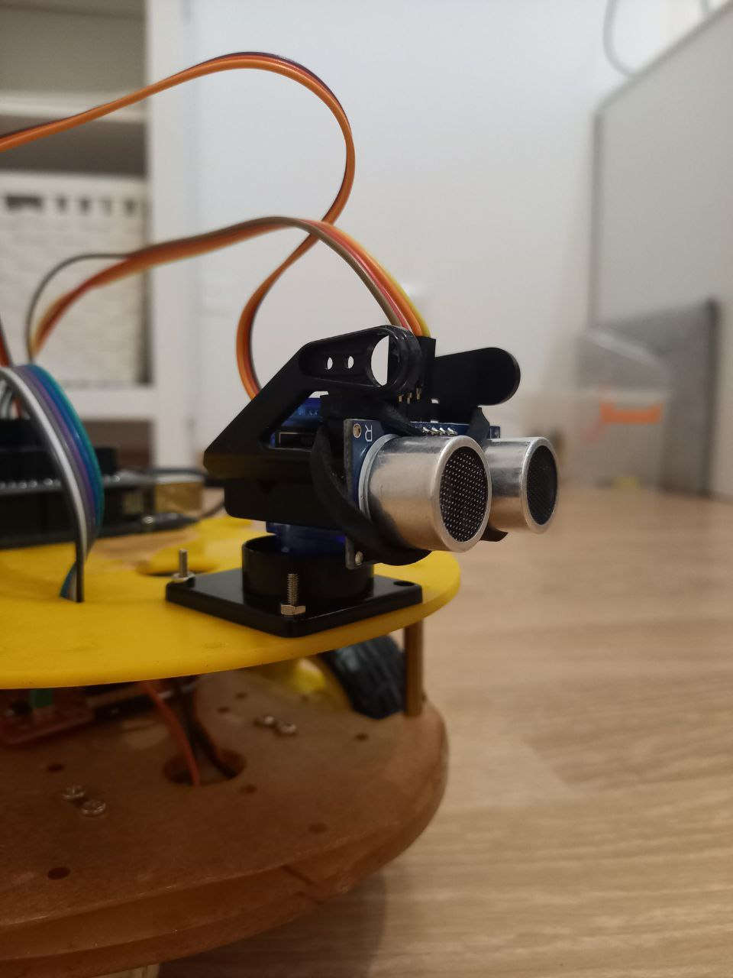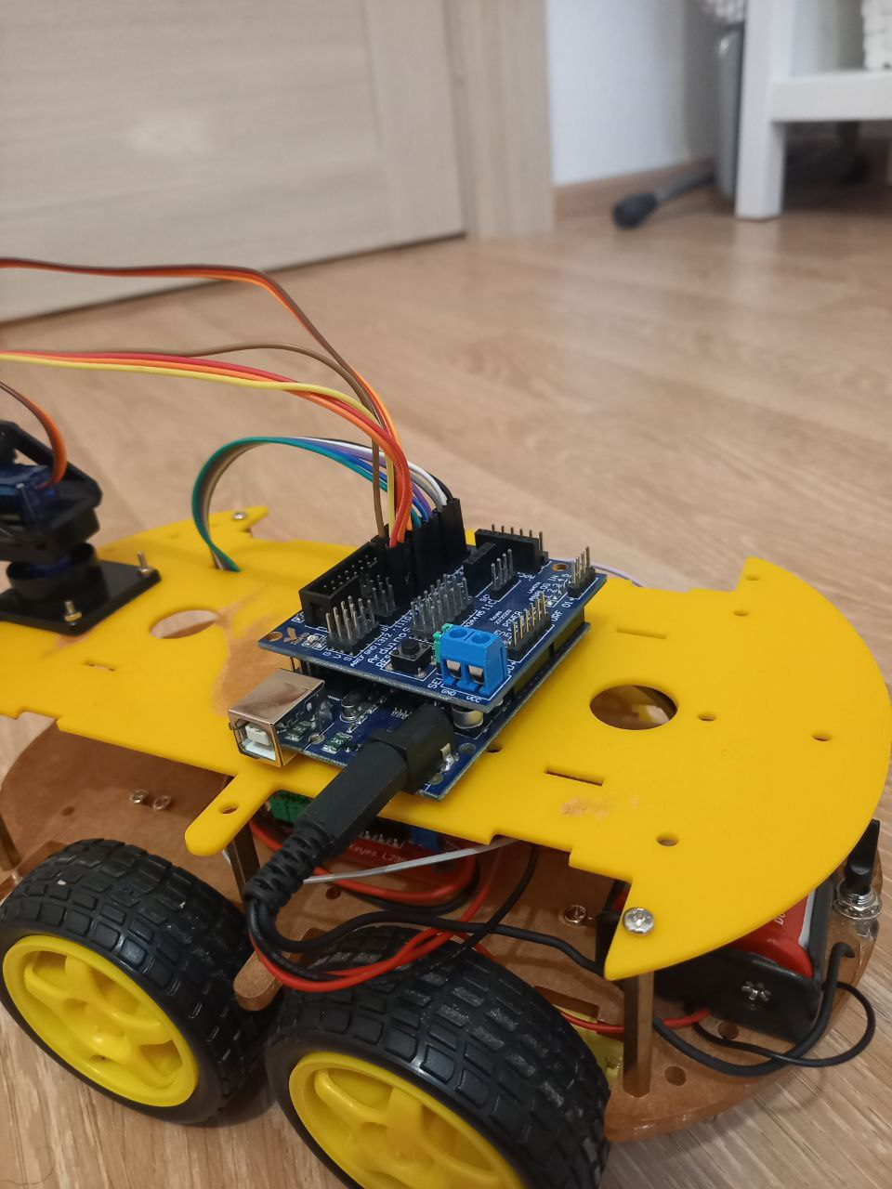

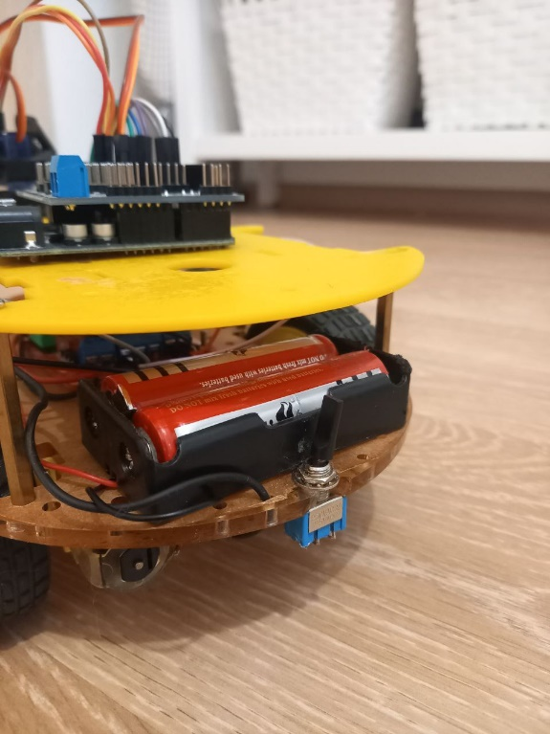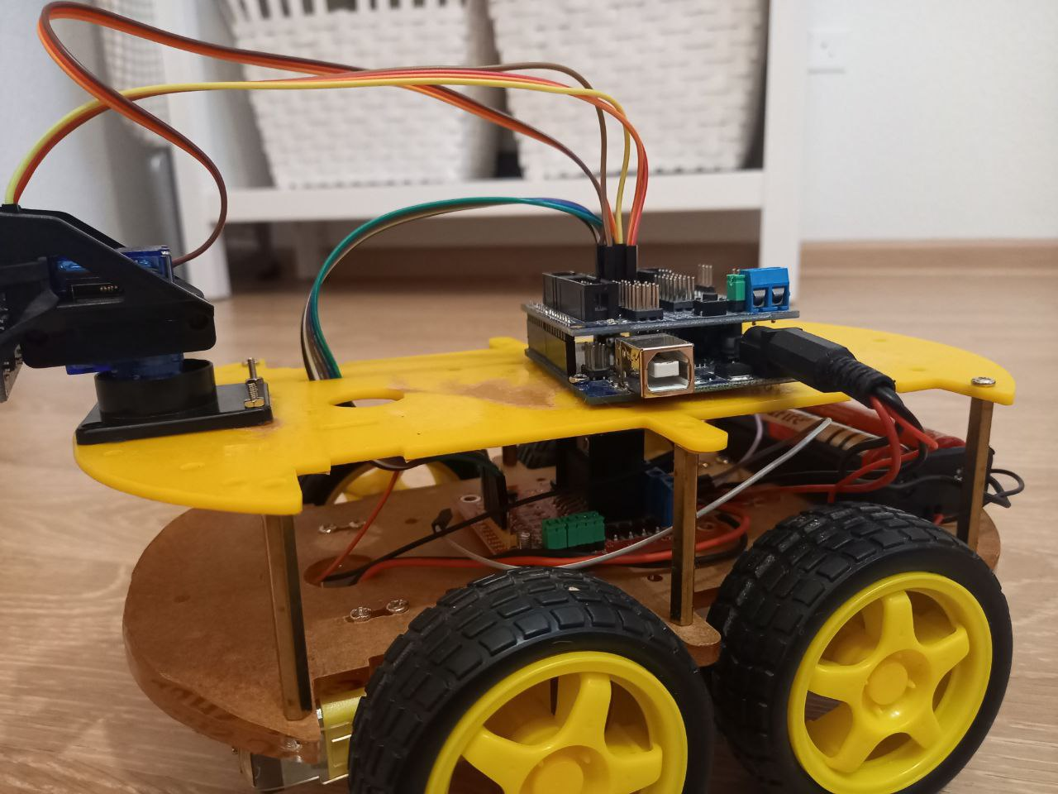

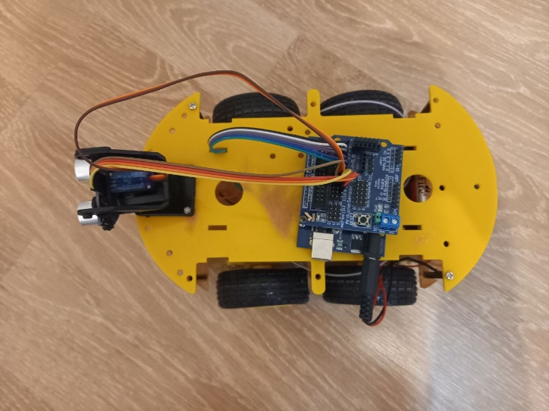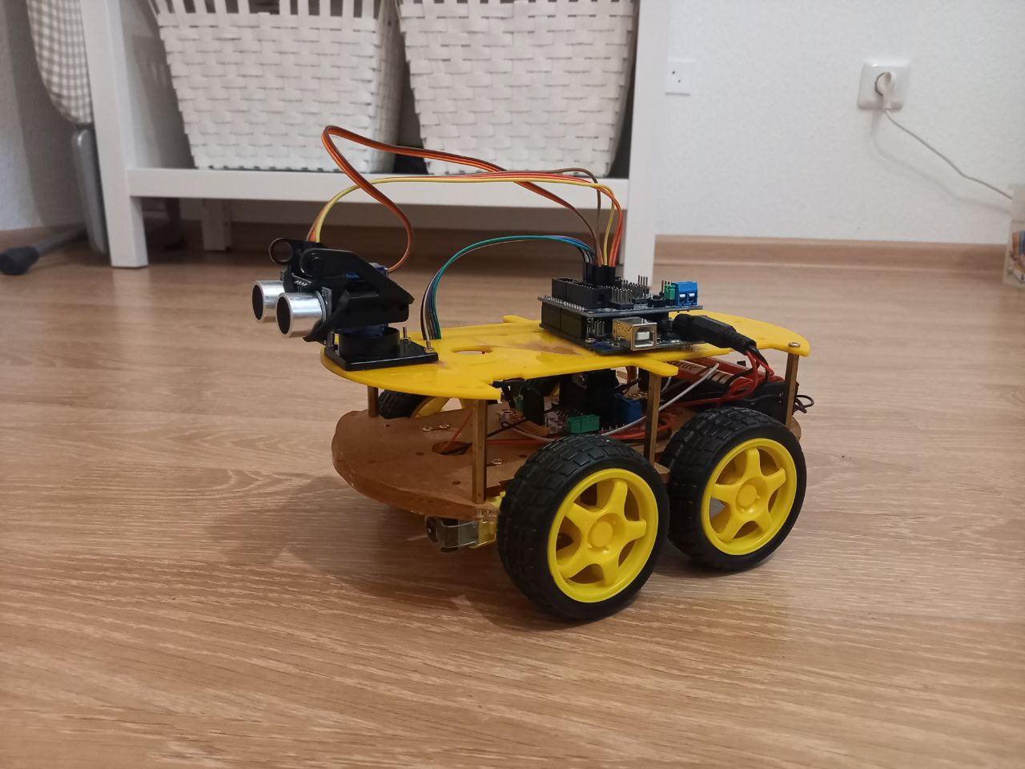

Программа

// Setup the servo motor

#include <Servo.h>

Servo myservo;            // инициализировать объект сервопривода

int servposnum = 0;

int servpos = 0;

// Setup Motor A (front and rear) pins

int enableA = 1;

int pinA1 = 3;

int pinA2 = 2;

// Setup Motor B (front and rear) pins

int enableB = 6;

int pinB1 = 5;

int pinB2 = 4;

// Setup Ultrasonic Sensor pins

#define trigPin 8

#define echoPin 9

void setup() {

  // Configure the pin modes for each drive motor

   pinMode (enableA, OUTPUT);

   pinMode (pinA1, OUTPUT);

   pinMode (pinA2, OUTPUT);

   pinMode (enableB, OUTPUT);

   pinMode (pinB1, OUTPUT);

   pinMode (pinB2, OUTPUT);

   // Configure the pin modes for the Ultrasonic Sensor

   pinMode(trigPin, OUTPUT);

   pinMode(echoPin, INPUT);

   // Turn pin into servo driver.

   myservo.attach(7);

}

void loop() {

  // Main code goes here and will run repeatedly:

     car(); // function keeps moving car forward while distance > 25 cm

     avoid(); // function makes car go back, turn slightly right to move forward in new direction

}

// Create motor functions

void motorAforward() {

digitalWrite (pinA1, HIGH);

digitalWrite (pinA2, LOW);

}

void motorBforward() {

digitalWrite (pinB1, LOW);

digitalWrite (pinB2, HIGH);

}

void motorAbackward() {

digitalWrite (pinA1, LOW);

digitalWrite (pinA2, HIGH);

}

void motorBbackward() {

digitalWrite (pinB1, HIGH);

digitalWrite (pinB2, LOW);

}

void motorAstop() {

digitalWrite (pinA1, HIGH);

digitalWrite (pinA2, HIGH);

}

void motorBstop() {

digitalWrite (pinB1, HIGH);

digitalWrite (pinB2, HIGH);

}

void motorAcoast() {

digitalWrite (pinA1, LOW);

digitalWrite (pinA2, LOW);

}

void motorBcoast() {

digitalWrite (pinB1, LOW);

digitalWrite (pinB2, LOW);

}

void motorAon() {

digitalWrite (enableA, HIGH);

}

void motorBon() {

digitalWrite (enableB, HIGH);

}

void motorAoff() {

digitalWrite (enableA, LOW);

}

void motorBoff() {

digitalWrite (enableB, LOW);

}

// Setup movement functions

void forward (int duration) {

motorAforward();

motorBforward();

delay (duration);

}

void backward (int duration) {

motorAbackward();

motorBbackward();

delay (duration);

}

void right (int duration) {

motorAbackward();

motorBforward();

delay (duration);

}

void left (int duration) {

motorAforward();

motorBbackward();

delay (duration);

}

void coast (int duration) {

motorAcoast();

motorBcoast();

delay (duration);

}

void breakRobot (int duration) {

motorAstop();

motorBstop();

delay (duration);

}

void disableMotors() {

motorAoff();

motorBoff();

}

void enableMotors() {

motorAon();

motorBon();

}

// Setup Ultrasonic Sensor distance measuring

int distance() {

  int duration, distance;

  digitalWrite(trigPin, HIGH);

  delayMicroseconds(1000);

  digitalWrite(trigPin, LOW);

  duration = pulseIn(echoPin, HIGH);

  distance = (duration/2) / 29.1;

  return distance;

}

// Setup the main car function

void car() {

int distance_0;

distance_0 = distance();

  // Keep moving forward in a straight line while distance of objects > 25cm

  while(distance_0 > 25)

  {

     // Keep moving servo motor back and forth to scan surroundings

     // This allows the ultrasonic sensor to see more to its left and right

     if(servposnum == 0)

     {

      myservo.writeMicroseconds (1500);   //  задаем среднюю точку, тем самым останавливая вал сервомотора

      servposnum = 1;

      delay(100);

     }

     else if(servposnum == 1)

     {

      myservo.writeMicroseconds (1800);   // задаем поворот сервопривода по ходу движения на лево "+300" от средней точки 1500

      servposnum = 2;

     delay(100);

     }

     else if(servposnum  == 2)

     {

      myservo.writeMicroseconds (1500);   //  задаем среднюю точку

      servposnum = 3;

      delay(100);

     }

     else if(servposnum == 3)

     {

      myservo.writeMicroseconds (1200);   // задаем поворот сервопривода по ходу движения на право "-300" от средней точки 1500

      servposnum = 1;

      delay(100);

     }

     motorAon();

     motorBon();

     forward(1);

     distance_0 = distance();

  }

  breakRobot(0);

}

void avoid()

{

    // Go back and turn slightly right to move car in new direction if object detected < 25cm away

    backward(320);

    right(100);

}